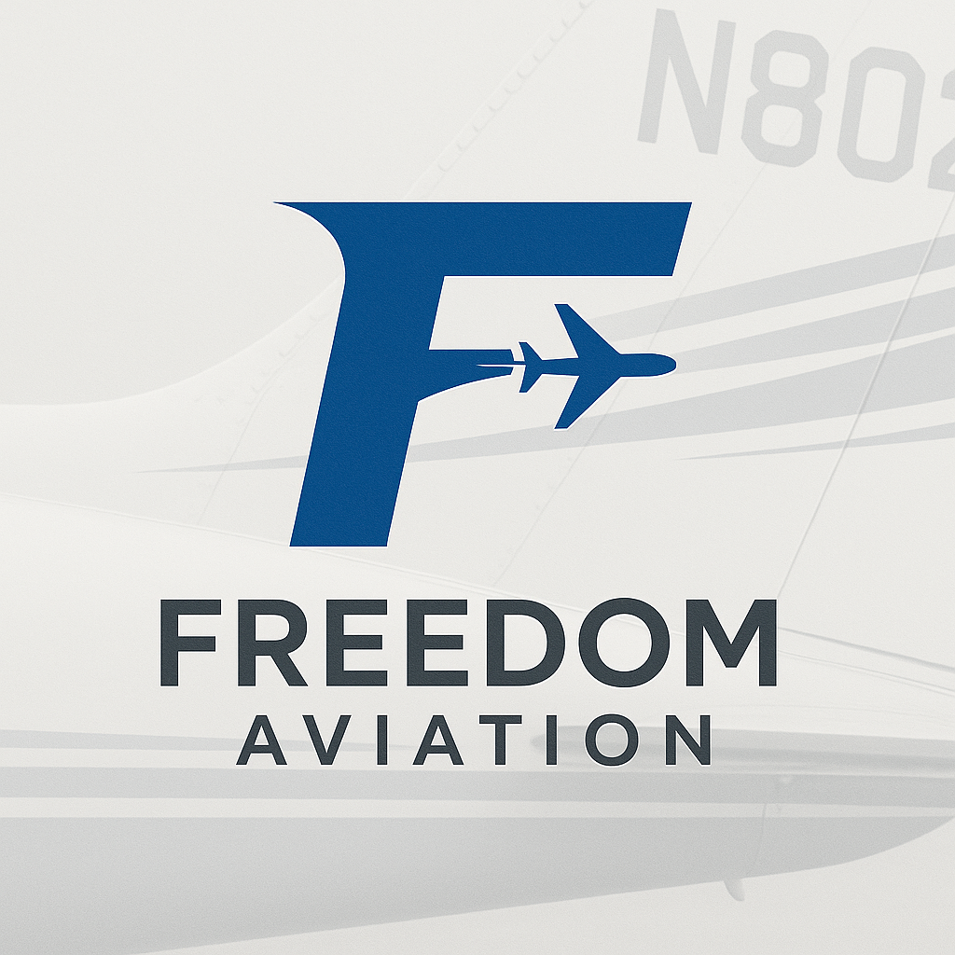

Membership Levels
All membership levels include a 24month Flight Review, and 6month IPC. Monthly Proficiency Club (Freedom 4th of every Month);

High $750 - Captain Flight Deck
For the multi-weekly flyer who needs multiple cleanings per month. Also has a aircraft (Cirrus, Diamond, etc) that needs multiple consumable items (TKS, Oxygen, Oil, etc.)
- 2 Full Details
- Weekly Bugwash Removal

Medium $500 - First Officer Flight Deck
For the occasional flyer who needs one major detail cleaning per month. Also has a aircraft (Cirrus, Diamond, etc) that needs multiple consumable items (TKS, Oxygen, Oil, etc.)
- 1 Full Detail (scheduled within app)
- 2 Bugwash Removal (scheduled within app)

Low $250
For the occasional flyer who may not need a major detail cleaning per month. Does not own a aircraft that needs multiple consumable items (Cessna, Piper). Oil included
- 1 Bugwash Removal per month (scheduled within app)
- 1 Full Detail every 2 months (scheduled within app)

Hangar Add-On ($1,000 Additional cost above and Beyond Membership)
Join the hangar waiting list (5 aircraft needed) to go from uncovered/covered parking into a Hangar! While you’re on your flying trip your vehicle will be kept in the hangar and will be detailed prior to your return!

One Time Services
- Full Detail
- Bug Wash Removal
- Oxygen & TKS Fill
- Restock Your Hangar

Potential service at one of the higher levels could be an option for clients to tell us (button on website) when they are going to fly and we can be at the airport before they take off to fill fluids, wash, pull out of hangar, etc. And being there when they get back to stack hangar/put plane away, refill fluids, bug wash, etc.

Instructors
All instructors are highly experienced 3+years, 2,000hr dual given, ATP licensed, Airline Pilot, CFII’s in Cirrus, Cessna, Piper, Diamond aircraft. As such can provide additional instruction/services above and beyond membership benefits
$100 per Hour
- Training towards next certificate
- International (Canada & Mexico) Training
- Mountain Training
- Aircraft Ferrying/Repositioning
- Proficiency/Currency/Fun Flying
- Airline Interview Prep
- Mock Checkrides

Other Services
- Aircraft Sales (Upgrade/Downgrade) to mission
- Scheduling Annual Maintenance Slots

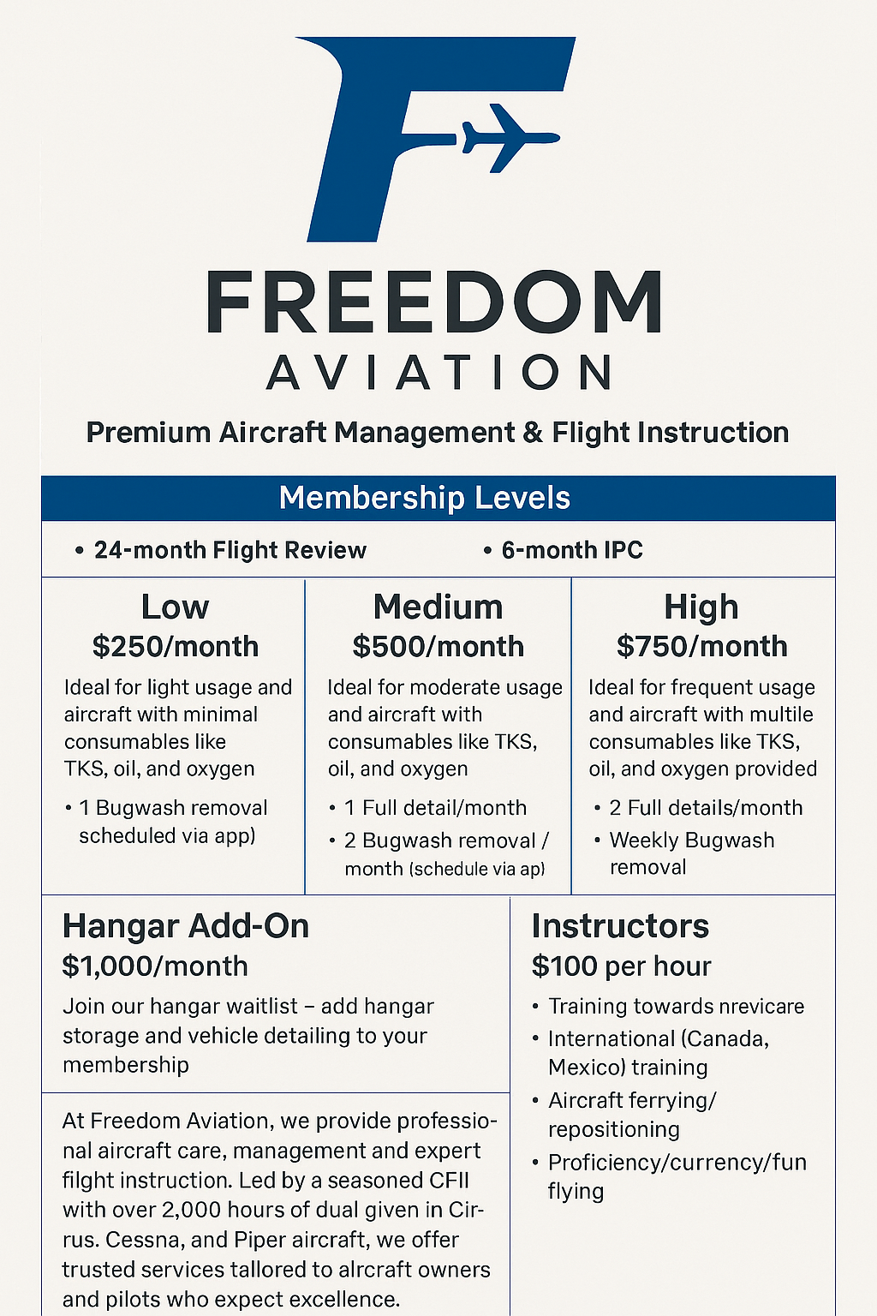

🔧

Business Plan Suggestions & Additions

1.

Clarify Target Market
- Clearly define aircraft type and owner profile you’re targeting (e.g., Cirrus owners flying 5–10 hours/month, corporate pilots, flight training clients, etc.)
- Consider adding a section:
Ideal Client Profile:
  - Owns a Cirrus, Diamond, or similar high-performance GA aircraft
  - Flies 2–8x per month
  - Prioritizes time, aircraft cleanliness, and professional flight instruction

2.

Add a Pricing Comparison / Value Chart
Show the value of your membership vs. à la carte pricing. This helps justify monthly fees:
Service | À La Carte | Included in Plan
Full Detail | $XXX | ✅ (1–2x/month)
Bug Wash | $XX | ✅
Oil / Oxygen / TKS | $XX | ✅
24-Month BFR / 6-Month IPC | $XXX | ✅

3.

Emphasize Convenience
Add language like:
“Let us handle the details—so you can just show up and fly.”
“Skip the prep and post-flight chores—we’ve got it covered.”

4.

Add a Referral Program
Referral Bonus: Get one free month for every pilot you refer who signs up.

5.

Add Premium Tiers / Concierge Add-On
For more exclusive clients:
Concierge Add-On ($250/month)
- Aircraft staged and pre-flighted
- Logbook entry prep
- Flight following & dispatch-style support
- Door-to-door car pickup/drop-off for

📣

Marketing Suggestions
- Add a QR code or booking link to your flyers
- Use testimonials from current aircraft owners if possible
- Consider adding a social media strategy and showcasing before/after photos of aircraft detailing
FREEDOM AVIATION
Premium Aircraft Management & Flight Instruction
WHY FREEDOM AVIATION?
We take care of your aircraft—so you can focus on flying.
From detailing and maintenance coordination to top-tier instruction, we offer convenience, care, and professional service tailored to busy aircraft owners.

✈️

Membership Levels

Low Tier – $250/month
Perfect for light usage with professional-grade care.
✔ 1 Full Interior & Exterior Detail per Month
✔ Garmin Database Updates
✔ TKS, Oxygen, and Oil Provided
✔ Coordinated Maintenance Scheduling
✔ IPC & Biennial Flight Review Included
✔ Optional: Leading Edge & Windscreen Cleaned After Each Flight (additional cost)
✔ Option for More Frequent Deep Cleans

Medium Tier – $500/month
Ideal for moderate usage and owner convenience.
✔ 2 Full Interior & Exterior Details per Month
✔ Garmin Database Updates
✔ Quarterly Top-Offs (TKS, Oxygen, Oil)
✔ Coordinated Maintenance & Pre-Flight Aircraft Staging
✔ Leading Edges & Windscreen Cleaned After Each Flight
✔ Interior Vacuumed & Trash Removed After Each Flight

High Tier – $750/month
Top-tier service for frequent flyers.
✔ Unlimited Interior & Exterior Deep Cleans
✔ Unlimited TKS, Oxygen, and Oil
✔ Garmin Database Updates
✔ Maintenance Scheduling & Support
✔ Free IPC & Biennial Flight Review
✔ Add Vehicle for On-Plane Detail at Additional Cost
✔ Upgrade Option: 1 Hour Ground + 1 Hour Flight Instruction per Month Included

Freedom Aviation – Business Plan

Executive Summary
Freedom Aviation provides premium aircraft management and expert flight instruction to private aircraft owners. Our services include monthly detailing, maintenance coordination, consumables replenishment, and professional instruction from ATP-certified CFII instructors.
We offer tiered memberships tailored to different levels of aircraft usage, ensuring flexibility, value, and exceptional service. Our goal is to simplify ownership, enhance safety and presentation, and maximize your time in the air.

Target Market
Our ideal clients:
- Own Cirrus, Diamond, Cessna, or Piper aircraft
- Fly 2–8 times per month
- Value convenience, cleanliness, and safety
- Prefer a one-stop solution for aircraft care, instruction, and management
We also serve:
- Business owners and professionals with demanding schedules
- Pilots looking for ongoing training, flight review, or mentorship

Membership Tiers

Low Tier – $250/month
For occasional flyers or owners of less complex aircraft.
- 1 Full Interior & Exterior Detail/month
- Garmin Database Updates
- TKS, Oil, and Oxygen provided at an additional cost per item
- Maintenance Scheduling & Coordination. Reserve slots at VectorAir, Legacy, Arapahoe Aero for our members to utilize. $100 squawk option to get a A&P onsite to fix squawks.
- IPC & Biennial Flight Review Included
- Optional: Leading Edge & Windscreen Cleaning after each flight (additional cost)
- Option to schedule more frequent deep cleans
- T-shirt Included (marketing strategy)

Medium Tier – $500/month
Designed for moderate flyers who want more convenience and support.
- 2 Full Interior & Exterior Deep Cleans/month
- Garmin Database Updates
- Quarterly Top-Offs (TKS, Oil, Oxygen) can be purchased at an additional cost

- Maintenance Scheduling & Coordination. Reserve slots at VectorAir, Legacy, Arapahoe Aero for our members to utilize. $100 squawk option to get a A&P onsite to fix squawks.

- IPC & Biennial Flight Review Included
- Pre-Flight Aircraft Staging only available with Freedom Aviation hangars includes minimum oil level, fuel level request etc.
- Leading Edge & Windscreen Cleaned after each flight
- Interior Vacuumed & Trash Removed
- T-shirt & golf polo included (marketing strategy)

High Tier – $750/month
Top-tier package for frequent flyers or high-performance aircraft owners.
- Unlimited Interior & Exterior Deep Cleans
- Garmin Database Updates

- Unlimited TKS, Oil, and Oxygen
- Full Maintenance Scheduling & Support. Reserve slots at VectorAir, Legacy, Arapahoe Aero for our members to utilize. $100 squawk option to get a A&P onsite to fix squawks.
- IPC & Biennial Flight Review Included

- Pre-Flight Aircraft Staging only available with Freedom Aviation hangars includes minimum oil level, fuel level request etc.

- Leading Edge & Windscreen Cleaned after each flight
- Option to Add Vehicle storage and cleaning only available for Freedom Aviation Hangars
- Upgrade: Add 1 Hour Ground + 1 Hour Flight Instruction per Month
- T-shirt, Golf Polo, Quarter Zip (Marketing Strategy)

Hangar Add-On – Varies $1,000-$2,000/month
Join the hangar waitlist (5 aircraft minimum to open space).
- Move from uncovered or shared parking to private hangar
- Vehicle storage, detailing available at an additional cost included while you’re on your trip

Instruction & Services

Instruction – $100/hr
Provided by highly experienced ATP, CFII instructors with 2,000+ hours given in Cirrus, Cessna, Piper, and Diamond aircraft.
- Certificate Training
- International (Canada & Mexico) Training
- Mountain Checkout
- Ferrying & Repositioning
- Airline Interview Prep
- Mock Checkrides

One-Time Services
- Full Aircraft Detail - Maybe require first detail to be this prior to entering monthly membership
- Bug Wash Removal
- Oxygen & TKS Fill
- Hangar Restock

Business Differentiators
- All-inclusive care model for aircraft and owner convenience
- Airline-experienced CFII instructors
- Hassle-free scheduling through a mobile platform
- “Freedom 4th” Monthly Proficiency Club
- Concierge Add-On available

Referral Program
Refer a pilot and get 1 FREE month of membership when they sign up—unlimited referrals allowed.

Marketing Strategy
- Leverage local networking at Centennial (APA) and nearby airports
- Build partnerships with FBOs, maintenance shops, and flight schools
- Branded Apparel to Memberships Levels
- Promote services on Instagram, YouTube, and Facebook with before/after content
- Use referral program to build a loyal client base
- Attend fly-ins, car/plane shows, and community aviation events
Greg’s notes Monday 6/2
- What’s most important to Greg as an AC owner is Maintenance - Scheduling his Annual, Flying to BJC for it, Squawks - perhaps charge $100 per squawk
- How many planes are based at centennial? To determine the market potential to take market share. Airport Authority or Jet Center might know
- Cindy at Willowbrook wants high end clientele, that’s important to her
- Create a 1-2 page teaser, then a full multi page brochure for potential clients
- What’s included in a Detail? Any hand-washing? First detail with a client should be more $ maybe $100-$200 more bc it may be in bad shape - then get them on the membership cleanings
- Create a PowerPoint presentation with pictures - this will be used for future clients, funding, insurance, hangar purposes
- Insurance include moving airplanes
- LLC Creation
- Operating Agreement - so we are both happy with take home pay etc. and don’t feel like one partner is taking advantage of the other partner

https://docs.google.com/spreadsheets/d/11ran3UXG6tKyaT0zn82fVVI_v3Ktk8NarvdE38kcyZE/edit?usp=sharing

Elevator Pitch

The Problem
Owning a small aircraft is rewarding but demanding. For private pilots, the time commitment goes far beyond flying: routine cleaning, bug washes, topping off fluids, updating avionics databases, scheduling maintenance, and keeping current with regulatory requirements all pile up. Most owners don’t have the time (or desire) to handle these details, but outsourcing them piecemeal is inconsistent, expensive, and inconvenient.

The Solution
Freedom Aviation provides a monthly membership service for small aircraft owners that takes the work out of ownership. For a flat fee, we handle the essentials of aircraft care, compliance, and readiness, so when you show up at the hangar, your airplane is ready to fly.
Membership includes:
- Bug wash, fluid refill and light detail every month
- Avionics database updates kept current
- Annual IPC (Instrument Proficiency Check) and Flight Review included at no extra charge
- Maintenance scheduling & coordination with trusted mechanics, so you never have to play phone tag with shops
- Concierge dispatch & readiness checks, ensuring your aircraft is prepped when you want to fly

Business Value Proposition
More flying, less fuss. Freedom Aviation is your personal flight department for a fraction of the cost. Instead of worrying about upkeep, you focus on flying — confident your aircraft is clean, compliant, and cared for.

Target Market
- Private pilots who own their own piston or light twin aircraft but don’t have the time or desire to keep up with cleaning, maintenance logistics, and compliance.
- Busy professionals who want turnkey readiness every time they get to the airport.
- Weekend flyers who want their airplane to feel “ready-to-go” without hours of prep.

Competition
Today, the only options are:
- Corporate-level management companies, designed for jets, not Cessnas or Barons.
- Independent services, like one-off washes or database updates — piecemeal, inconsistent, and often unreliable.
Freedom Aviation is the first to combine all owner essentials into a single membership plan built specifically for GA aircraft.

Call to Action
Skip the chores, fly more. Become a Freedom Aviation member today.

Dear Avemco,
We are in the process of establishing an aviation services company called Freedom Aviation and need insurance coverage to meet airport requirements. We are not yet incorporated as an LLC and have no current revenues, but we would like to secure quotes so we understand the cost structure as we finalize our setup. To operate out of Centennial Airport as we plan to they require these minumum insurance policies.
The minimum required coverages are as follows:
- Premises Liability – $1,000,000 CSL per occurrence (Bodily Injury & Property Damage).
- Products & Completed Operations Liability – $1,000,000 per occurrence.
  - With respect to Aircraft Washing/Detailing Services, a minimum sublimit of $100,000 per person is permitted.
- Aircraft Liability – $1,000,000 CSL per occurrence (Bodily Injury including passengers & Property Damage).
  - With respect to Passenger Bodily Injury, a minimum sublimit of $100,000 per person will be permitted.
- Motor Vehicle Liability – $500,000 CSL per occurrence (Bodily Injury & Property Damage), applicable if using service vehicles on the Air Operations Area.
To assist in providing a preliminary quote, here is our current information: We are pre-revenue, not yet incorporated (planning LLC formation). Our services will be based at Centennial airport in Centennial Colorado. We plan to provide cleaning and service to our clients aircraft. Our clients are owner pilots who own small propeller driven airplanes, and we will be servicing, cleaning, and maintaining their airplanes. Under the FAA and KAPA definitions of our services we are providing aircraft cleaning services. If you have any further questions about our operations pleas feel free to ask.
We would appreciate estimates of annual premiums and any guidance on binding coverage once the LLC is formally established.
Thank you for your assistance.
Best regards,
Freedom Aviation Team
Noah Berman
9706182094
noahberman14@gmail.com

